|  |  |
| --- | --- |
| Procedure:  **QP-121** | Pages:  **3** |
| Printed:  **8/22/2024** | Released: **12/05/2023**  Rev. Num: **6** |
| Authorized By:  **Manufacturing Manager** | |

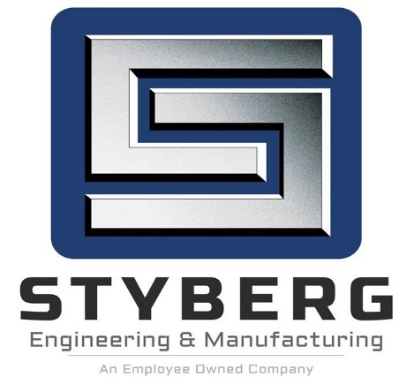

**PRODUCTION EQUIPMENT MAINTENANCE**

1. **Purpose and Scope**

**PURPOSE**

To ensure production equipment is appropriately maintained through a system of planned preventive and predictive maintenance

**SCOPE**

This procedure applies to all production equipment

1. **Definitions**

**Predictive Maintenance:** A form of preventive maintenance that uses historical data to

predict failures and prevent breakdowns, through timely repair.

**Preventive Maintenance (PMs):** A planned activity of equipment maintenance based

on scheduled service and replacement of parts.

1. **Process Owners**

**Manufacturing Manager**

**Process Designees: Department Supervisor**

**Lubrication Specialist**

**Machine Repair Supervisor**

**Machine Repair Technician**

**MRO Buyer**

**Production Operator**

**SPC Coordinator**

1. **Procedures**

**Machine Repair Supervisor**

**Develops Preventive Maintenance Procedure**

The Machine Repair Supervisor develops a preventive maintenance procedure for each piece of production equipment, based on manufacturer recommendations, standard practices, and judgment. Tasks to be performed should be specific in nature and not left up to the judgment of the technician performing the maintenance. The procedure or “checklist” can be accessed by double clicking on the machine asset number on the “Machines” screen in the ERP System.

The “Machines” screen has field “Threshold” that determines when a PM is due based on labor hours. The supervisor shall determine and enter threshold hours, which will cause an email to be sent to the supervisor when the threshold hours are met, based on labor entry for that machine. This email alerts the supervisor that preventive maintenance is due.

**Maintains Maintenance Schedule**

The Machine Repair Supervisor creates and maintains a scheduled maintenance plan identifying current and past due requirement. To ensure that tasks can proceed as scheduled, the M.R. Supervisor coordinates the availability of equipment, parts, material, personnel and outside services. Regularly scheduled maintenance is controlled via ERP System and is determined by the past repairs on file and the top 20% of machines due to their load requirements. The ERP System computer software sends out email alerts when preventive maintenance is due.

**Issues Repair/Work Order**

When repair work is scheduled, the Machine Repair Supervisor will issue a repair/work order to alert affected departments. Repair/work orders are done electronically in the ERP System.

**Assigns Maintenance Tasks**

Maintenance Technicians are assigned work by the Machine Repair Supervisor based on scheduling, workloads, need and computer-generated reminders from the ERP System.

**Extension of Preventive Maintenance**

There are times when Maintenance schedules are full, such as an important work center being down for repairs, and there isn’t enough manpower to perform needed PMs. There are also times when production schedules become full and a department supervisor determines that he can’t shut down a machine long enough to perform preventive maintenance. When this occurs, the maintenance supervisor will document the need to extend the preventive maintenance due on the “Extension of Scheduled Preventive Maintenance.”

**Monitors Replacement Parts Inventory**

The Machine Repair Supervisor will monitor the inventory of replacement parts periodically to assure they are stored in a manner, which prevents damage or deterioration. Parts that are not on hand will be ordered through Purchasing. Any parts needed that are considered high cost, will be ordered with the assistance of the Manufacturing Manager.

**Reviews and Modifies Procedures**

The Machine Repair Supervisor will review downtime results, repair history, quality records, and other information annually and modify equipment maintenance procedures based on cumulative data and experience.

1. **References**

**5.1 Related Procedure**

None

**5.2 Reference Documents**

None

1. **Records**

None

1. **Policy References**

None

1. **Revision History to Procedure QP-121**

|  |  |  |  |
| --- | --- | --- | --- |
| **Chg. No.** | **Date** | **Rev.** | **Change Description** |
| 1 | 2/13/1998 | 0 | Creation of Document |
| 2 | 1/29/1999 | 1 | Added "to assure they are stored in a manner to prevent damage or deterioration" to section 4.9. Added section 4.17. |
| 3 | 8/7/2006 | 2 | Inserted 4.7 and 4.8 regarding extension of scheduled maintenance. Deleted section 7 'Governing Policies' and added form #PM-100 to records. |
| 4 | 1/12/2018 | 3 | Revised for ISO 9001 / IATF 16949 |
| 5 | 4/19/2018 | 4 | Wording added in section 4.1: Tasks to be ……. The maintenance.  Added to paragraph #4.1 The procedure … screen in Oracle.  The “Machines” screen … preventive maintenance is due |
| 6 | 12/05/2023 | 5 | Changed Document Type from Instruction to Procedure.  Section 5- Added References  Section 5.1-Added Related Procedures  Section 6 -Added Records  Section 7- Added Policy References  Section 8-Removed “of”, added “History to Procedure.”  Added-Revised Styberg Logo, Revision History Block,  Changed revision number from 2 to 6 to reflect correct change history  Section 4 “oracle” was changed to “ERP System” 5 times |